Crystal Violet-Hydroxide Reaction. Using Interactive Webpages to Start Quantum Theory Calculations

John W. Keller* and Arianna L. Demmerly

Keywords: crystal violet, dft, webmo, jsmol, transition state, cluster, activation energy, LUMO, HOMO, uv-vis, orca

## INTRODUCTION

Computational chemistry has gradually been introduced into the chemistry curriculum during the past decades due to the increased use of computational methods in chemical research, the increased speed and decreased cost of computational hardware, and improvements in molecular graphics programs. Published computational exercises have been mostly designed for upper division chemistry courses where they delve into computational mathematics or organic mechanism details. These have often required specialized computational software which is installed in a computer lab accessible only to the smaller upper division classes or general chemistry (GC) honors sections.1 Rarely, entire classes gain access to these facilities.2-4

The potential user base for computational chemistry instruction has widened with the introduction of the WebMO program.5 WebMO has a number of features that recommend it for use in large enrollment classes: it requires no software installation by the user besides a web browser; it can use a variety of computational packages including Gaussian, ORCA, MOPAC, xTB, GAMESS, and others; computational servers may be installed either locally or in the cloud; and jobs are saved in a database, allowing users to log back in after completing a calculation to check their results. Several GC computational exercises using WebMO have been reported; most focus on VSEPR theory.6-8 Labs related to resonance9 and the inductive effect10 have also been reported. Esselman and Block used embedded WebMO molecular orbital files to teach a modified VSEPR theory.11 Computational chemistry has been introduced into secondary schools.12

To date, computational applications in GC deal mostly with the geometries of small molecules7, 12 and studying the bond orders and MOs of resonance stabilized ions and molecules.9 Moving into larger chemical systems faces certain barriers. With some students, the complexity of larger organic molecules leads to sensory overload. But also, obtaining realistic results may require one or more density functional theory (DFT) calculations that cannot be completed within a typical lab period. Even using software with an intuitive graphical user interface, the build-optimize-analyze cycle for a larger molecule is still a challenge.

This article describes how lab students can get a quick start on DFT calculations of large molecules by downloading the pre-optimized structures from interactive webpages. These molecules are ones that occur in the crystal violet (CV) alkaline hydrolysis reaction, which is the subject of a popular 2nd semester GC kinetics experiment. Based on the calculation results, students are challenged to analyze resonance stabilization and charge distribution within CV; the nature of the reaction transition state, energies of activation and reaction; and the HOMO-LUMO energy gaps in CV and the colorless crystal violet alcohol product CVOH.

## ALKALINE HYDROLYSIS OF CRYSTAL VIOLET

Crystal violet cation (CV) reacts with aqueous NaOH to give the colorless crystal violet alcohol (CVOH) product (Equation 1). The reaction progress is followed by measuring the decrease in CV absorbance at 590 nm. This fact, and the relatively slow reaction rate, make the experiment suitable for a GC lab.13-16 Kinetics studies on this second-order reaction were originally reported by Richie et al.17, 18 and others.19-22 CV reacts slowly compared to other triarylmethyl cations due to the strong stabilization of the cationic center by the dimethylaminophenyl substituents.

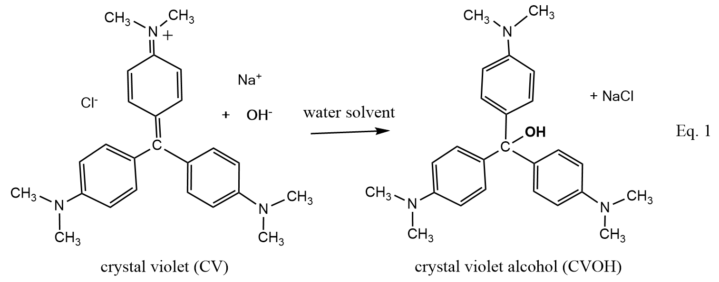

Obtaining semi-realistic reaction energies computationally for this reaction requires use of a DFT method with the SMD polarizable continuum model;23 a medium-size basis set; and, as a reactant, a water-hydroxide ion cluster. Experimental24-26 and theoretical27-34 studies have shown that hydroxide ion is strongly hydrogen-bonded in water. Molecular dynamics simulations of aqueous NaOH show 3, 4 or 5 waters donating H-bonds to O, but with OH rarely donating. Thus, reaction of hydroxide with CV involves initial breaking and loosening H‑bonds, which is a major contributor to the activation barrier. Richie et al. reported a DG‡ of 18.4 kcal mol-1 (DH‡, 15.3 kcal mol-1) at 25.0 oC with DGorxn of -6.3 kcal mol-1 (DHorxn, -6.6 kcal mol-1).17 Derivation of these values from Richie’s data is given in the Supporting Information. The calculations in this computational exercise use a bridged 4-water-OH- cluster (Fig. 1a), which is one of the most stable 4-water-OH- geometries.27 This cluster size gives activation and reaction energies that are somewhat low (6.8 kcal mol-1and -10.5 kcal mol-1, respectively). Larger clusters give more accurate values but these require longer calculation times and in our view present unnecessary structural complexity.

These molecules and their water complexes are first presented on interactive webpages from which the structure files can be downloaded; these included CV, CVOH, and 4-water clusters of OH-, CVOH, and the CV-OH transition state.35

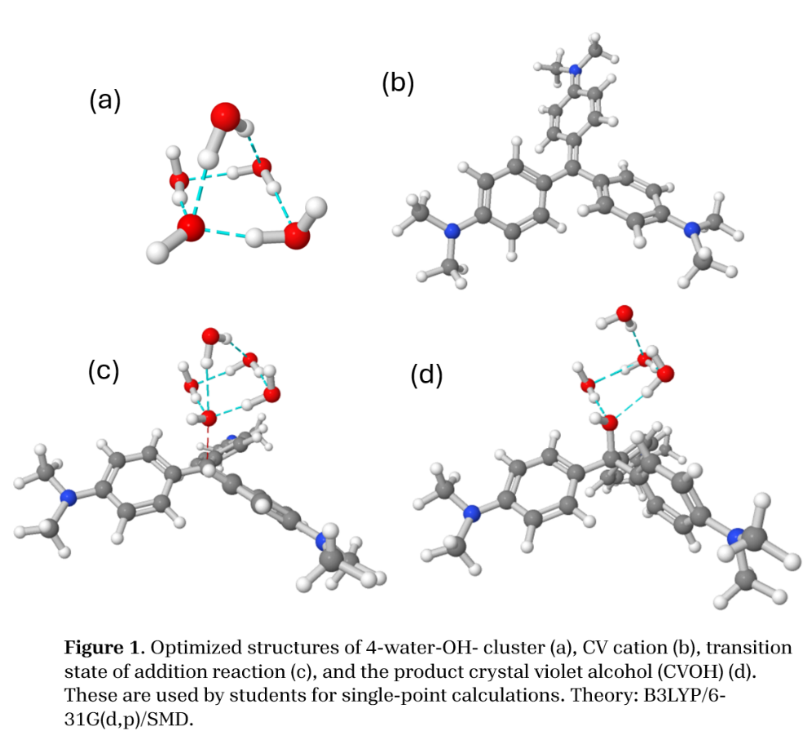

## INSTRUCTIONAL SETTING

University of Alaska Fairbanks has an American Chemical Society approved chemistry major program. The science and engineering majors’ GC series is offered each semester; an atoms-first textbook is used. The course enrolls about 140 students in the spring semester and 60 in the fall. Lab classes are taught by graduate students or final-year undergraduates and contain 20 students.

## LEARNING OBJECTIVES

The goal of this lab is foster students’ appreciation for the unseen phenomena at work during a simple chemical reaction, and how these can be illuminated using quantum theory. Delving deeply into the crystal violet bleaching reaction reveals the occurrence of multiple concepts from a typical science majors course, including Lewis formulas, resonance, electronegativity, polar bonds, aspects of molecular orbital theory, exo- and endothermic reactions, transition states, and the electromagnetic spectrum. Some of these are addressed explicitly in the worksheet.

*Bond polarity.* Electronegativity differences in bonded atoms cause partial charge separations, which are estimated as part of an ORCA single point energy calculation. Orca calculates partial atomic charges by three methods: Mulliken, Loewdin, and Mayer. WebMO reports Loewdin charges in the View Job page. Students should be able display the partial charge output, record values for different atoms on the worksheet, and rationalize why they might differ from zero. Scaffolding is provided by discussing partial atomic charges in HF and NH3 molecules in the handout (see the Supporting Information). .

*Resonance*. This section of the lab gives students another chance to grapple with the difficult concept of resonance.36 To refresh memories, resonance in formate ion is discussed in the handout. The Lewis formula of CV (Eq. 1) shows one nitrogen with a +1 formal charge. However, a DFT calculation shows Loewdin partial charges on all three N’s are identical (-0.038). In additon, the bond lengths and angles are invariant in the three aryl groups, and the electron density and electrostatic potential surfaces appear to be 3-fold symmetric. Thus, CV is a hybrid of 3 (or more) formulas. The worksheet provides skeletal formulas and students are asked to fill in missing multiple bonds and formal charges and explain their answer in terms of the symmetry perceived in the JSmol surfaces.

*Energy change*. Some students master the logic of a relative energy scale. Others struggle when the calculated absolute energies of reactants and products are all negative, as they are for ORCA calculations. Skaffolding is provided by giving a practice DErxn calculation in the pre-lab.

*UV-vis spectroscopy and the electromagnetic spectrum*. Part 3 investigates why CV is violet, while CVOH is colorless. This section builds on previous knowledge about atomic emission and absorption spectra. Here the orbitals in question are the HOMO to LUMO, which can be viewed in WebMO. λmax. values for CV and CVOH are calculated from HOMO and LUMO energies which are then substituted into DE=hν. This equation and the required constants to 4 significant figures are provided. Nevertheless, we found that about one-quarter of the reports failed to arrive at the correct λ max values due to algebra errors, or calculator errors related to exponents, or transcription errors.

Assuming that the spectra are due to promotion of an electron from the HOMO to LUMO gives λmax values of 465 nm and 258 nm for CV and CVOH, respectively. The experimental values are 590 nm and 280 nm.. A higher level of theory (TDDFT with M06-2X/def2-TZVP) is worse at 440 nm.

*Computational chemistry*. The aim of this lab to show students how to carry out basic quantum theory calculations, yet include some shortcuts in order to keep the time required within one lab period. It is still necessary for students to do a basic WebMO+ORCA calculation. In theory this would enable students to use WebMO and ORCA (or other computational engines) in future chemistry classes, or projects. OurWebMO site is available throughout the semester, which allows students to log on any time, build or import molecules, and carry out a simple calculations.

## JSmol INTERACTIVE WEBPAGES

In our experience, students encounter various difficulties with molecular modeling software especially when they must build and optimize a molecule prior to getting the “answer.” For example, WebMO’s Cleanup button places hydrogens on any atom that does not have a full set of bonds; this is a problem if the correct Lewis structure is not drawn. Optimizing the structure once it is built may require many minutes, and even then it may arrive at an incorrect isomer or conformer. A work-around to provide the structures in easy-to-understand graphical format that can be directly imported into the WebMO workspace. A 2-min energy calculation then provides relevant details such as energy content, charge distribution, and bond distances. ORCA also calculates molecular orbital energies and spatial distributions.37

Fig. 2 shows two of the pages that introduce students to crystal violet quantum calculations.35The index page (a) links to sub-pages showing the structures in Fig. 1. Right clicking one of these pages brings up a menu offering to save the structure on the local computer in the MDL molfile format (.mol). After logging into WebMO, the File, Import Molecule menu is used to bring the molecule into the workspace. Fig. 1(b) shows one of three pages that are not downloaded but are used to illustrate surfaces of CV+ that are discussed on the student worksheet. The surfaces are loaded only after the appropriate button is selected. The total electron density surface provides visual evidence that CV+ is completely symmetric despite its formula showing only one resonance form.

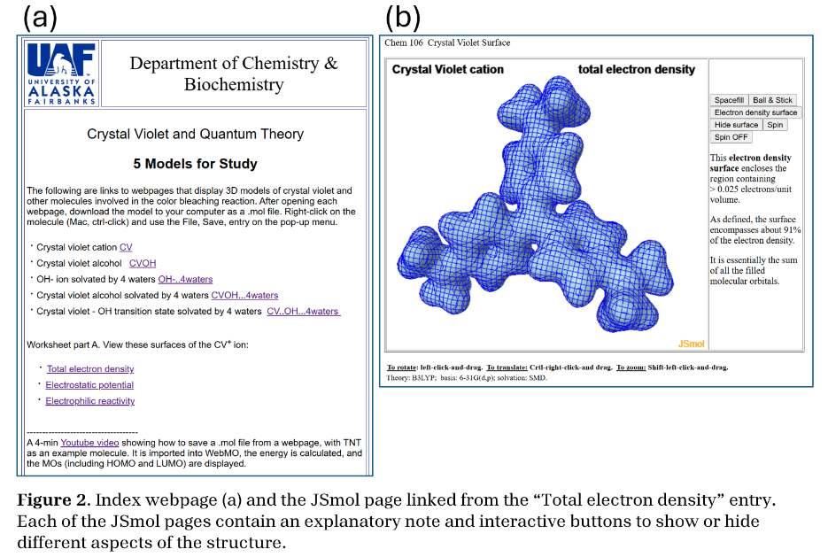HTML files for the JSmol web pages and web server instructions are in the Supporting Information. JSmol is the web version of the Jmol molecular graphics program;38, 39 it requires that the JSmol program files be installed on the web server. The web pages can be hosted on any web server: in the cloud or on premises. At UAF the JSmol web pages are hosted on a virtual machine installed on the WebMO server. If the web servers reside inside a university’s firewall-protected network, they can be made world readable by installation of a DNS tunnel, which must be done by the campus network security office. This setting allows remote learning chemistry students to participate in crystal violet quantum theory lab.

## WEBMO AND COMPUTE SERVERS

The enterprise edition of WebMO v 23.0.017e was used for this exercise. During the week when the lab was scheduled certain modifications were made to simplify job input and speed up calculations. (1) WebMO’s orca.html file was edited to make B3LYP and 6-31G(d,p) the default method and basis set; multiplicity is singlet; and the water solvent and cartesian coordinates are selected. (2) A custom template “Molecular Energy – 106” was created, which was a copy of the WebMO ORCA Molecular Energy template, and which included a %cpcm section specifying the SMD polarizable continuum model. (3) The Charge setting on the WebMO Job Options page is taken from the imported .mol file, which is non-zero only for CV. In that case the .mol file stored on the JSmol webserver is modified to replace +1 with +3 for the quaternary N. WebMO interprets that as +1.

In this lab setup, a head node runs WebMO, ORCA and a virtual machine containing JSmol and JSmol webpages. Two multi-core remote servers are networked with the WebMO server. In the WebMO Interface Manager the maximum number of cores on each server was set to 16 and the default number of cores per job was set to 8. This allows two calculations to proceed simultaneously, and forces subsequent jobs out onto the remote servers.

A major concern with this experiment is the time required for multiple simultaneous lab sections to do single-point DFT calculations on molecules with 570 (for CV) to 690 (CVOH-4-water cluster) basis functions. Whether this is feasible or not depends on several factors: the efficiency of the compute engine program; the number and processing power of available servers; the level of theory of the calculations; the number of sections, and students per section and whether they work singly or in pairs. Our setup uses Gaussian 16 or ORCA 6.0, three compute servers with off-the-shelf 16-core processors with hyperthreading enabled, B3LYP/6-31G(d,p)/SMD theory, and a maximum of 2 sections with 20 students per section working in pairs. The scheduled lab time at UAF is 3 h. Under these conditions most students complete the computations within 2 h.

This lab has been completed by two 2nd -semester GC classes: a 7-section class in Spring 2024 and a 3-section class in Fall 2024. The exercise was the same in the two semesters, except that the background compute engine was Gaussian 16 for the former and ORCA 6.0 for the latter. The molecular geometries, energies, charges, and surfaces were identical, however ORCA calculations were about twice as fast as Gaussian. Also, an ORCA single point energy calculation includes the coeficients for the molecular orbitals, whereas Gaussian requires a separate Molecular Orbitals job in WebMO.

## References

1. Ruddick, K. R.; Parrill, A. L.; Petersen, R. L. Introductory Molecular Orbital Theory: An Honors General Chemistry Computational Lab As Implemented Using Three-Dimensional Modeling Software. *J. Chem. Educ.* **2012**, *89* (11), 1358-1363. DOI: 10.1021/ed2003719.

2. Paselk, R. A.; Zoellner, R. W. Molecular Modeling and Computational Chemistry at Humboldt State University. *J. Chem. Educ.* **2002**, *79* (10), 1192. DOI: 10.1021/ed079p1192.

3. Feller, S. E.; Dallinger, R. F.; McKinney, P. C. A Program of Computational Chemistry Exercises for the First-Semester General Chemistry Course. *J. Chem. Educ.* **2004**, *81* (2), 283. DOI: 10.1021/ed081p283.

4. Metz, I. K.; Bennett, J. W.; Mason, S. E. Examining the Aufbau Principle and Ionization Energies: A Computational Chemistry Exercise for the Introductory Level. *J. Chem. Educ.* **2021**, *98* (12), 4017-4025. DOI: 10.1021/acs.jchemed.1c00700.

5. Polik, W. F.; Schmidt, J. R. WebMO: Web-based computational chemistry calculations in education and research. *WIRES Comp. Mol. Sci.* **2022**, *12* (1), e1554. DOI: <https://doi.org/10.1002/wcms.1554> (acccessed 2024/07/03).

6. Medrano, A. L.; Gilbert, T. M.; Morales, C. M. Shortcomings of the VSEPR Model for Hypercoordinate Species and Its Presentation in General Chemistry. *J. Chem. Educ.* **2023**, *100* (9), 3659-3666. DOI: 10.1021/acs.jchemed.3c00415.

7. McNaught, I. J. Testing and Extending VSEPR with WebMO and MOPAC or GAMESS. *J. Chem. Educ.* **2011**, *88* (4), 421-425. DOI: 10.1021/ed900038a.

8. Martin, C. B.; Vandehoef, C.; Cook, A. The Use of Molecular Modeling as “Pseudoexperimental” Data for Teaching VSEPR as a Hands-On General Chemistry Activity. *J. Chem. Educ.* **2015**, *92* (8), 1364-1368. DOI: 10.1021/ed500806h.

9. Santos, A. V. B.; Rupprecht, A. J.; Ogawa, K.; Schneider, P. W.; Brown, A. M.; Santos, H. C.; Simpson, S. Exploring Student Misconceptions in Bonding and Resonance: A Computational Chemistry Exercise for General Chemistry Laboratory. *J. Chem. Educ.* **2024**. DOI: 10.1021/acs.jchemed.4c00694.

10. Stepanova, V. A.; West, J. K. Exploring the Inductive Effect through Computational Modeling: A General and Organic Chemistry Lab Experiment. *J. Chem. Educ.* **2024**, *101* (7), 2815-2822. DOI: 10.1021/acs.jchemed.4c00001.

11. Esselman, B. J.; Block, S. B. VSEPR-Plus: Correct Molecular and Electronic Structures Can Lead to Better Student Conceptual Models. *J. Chem. Educ.* **2019**, *96* (1), 75-81. DOI: 10.1021/acs.jchemed.8b00316.

12. Hrubeš, J.; Jaroš, A.; Nemirovich, T.; Teplá, M.; Petrželová, S. Integrating Computational Chemistry into Secondary School Lessons. *J. Chem. Educ.* **2024**, *101* (6), 2343-2353. DOI: 10.1021/acs.jchemed.3c00908.

13. Cannon, J. F.; Gammon, S. D.; Hunsberger, L. R. KineticsLab: The Crystal Violet/Sodium Hydroxide Reaction. *J. Chem. Educ.* **1994**, *71* (3), 238. DOI: 10.1021/ed071p238.1.

14. Corsaro, G. Colorimetric chemical kinetics experiment. *J. Chem. Educ.* **1964**, *41* (1), 48. DOI: 10.1021/ed041p48.

15. Kazmierczak, N.; Vander Griend, D. A. Improving Student Results in the Crystal Violet Chemical Kinetics Experiment. *J. Chem. Educ.* **2017**, *94* (1), 61-66. DOI: 10.1021/acs.jchemed.6b00408.

16. Knutson, T. R.; Knutson, C. M.; Mozzetti, A. R.; Campos, A. R.; Haynes, C. L.; Penn, R. L. A Fresh Look at the Crystal Violet Lab with Handheld Camera Colorimetry. *J. Chem. Educ.* **2015**, *92* (10), 1692-1695. DOI: 10.1021/ed500876y.

17. Ritchie, C. D.; Wright, D. J.; Huang, D. S.; Kamego, A. A. Cation-anion combination reaction. XII. Rates, equilibriums, and activation parameters for reactions of triarylmethyl cations in aqueous solution. *J. Am. Chem. Soc.* **1975**, *97* (5), 1163-1170. DOI: 10.1021/ja00838a034.

18. Ritchie, C. D.; Skinner, G. A.; Badding, V. G. Solvent Effects on the Reactions of Stabilized Carbonium Ions with Nucleophiles. *J. Am. Chem. Soc.* **1967**, *89* (9), 2063-2071. DOI: 10.1021/ja00985a017.

19. Salahudeen, N.; Rasheed, A. A. Kinetics and thermodynamics of hydrolysis of crystal violet at ambient and below ambient temperatures. *Scientific Reports* **2020**, *10* (1), 21929. DOI: 10.1038/s41598-020-78937-4.

20. Beach, S. F.; Hepworth, J. D.; Mason, D.; Swarbrick, E. A. A kinetic study of the hydrolysis of crystal violet and some terminal and bridged analogues. *Dyes and Pigments* **1999**, *42* (1), 71-77. DOI: <https://doi.org/10.1016/S0143-7208(99)00010-8>.

21. Fox, B. M.; Hepworth, J. D.; Mason, D.; Hellas, G. The hydrolysis of Brilliant Green and some derivatives. Part 2. The kinetics of the hydrolysis of 3- and 4-substituted derivatives of Brilliant Green. *J. Chem. Soc., Perkin Trans. 2* **1982**, (8), 987-991, 10.1039/P29820000987. DOI: 10.1039/P29820000987.

22. Ritchie, C. D. Cation–anion combination reactions. 26. A review. *Can. J. Chem.* **1986**, *64* (12), 2239-2250. DOI: 10.1139/v86-370.

23. Marenich, A. V.; Cramer, C. J.; Truhlar, D. G. Universal Solvation Model Based on Solute Electron Density and on a Continuum Model of the Solvent Defined by the Bulk Dielectric Constant and Atomic Surface Tensions. *The Journal of Physical Chemistry B* **2009**, *113* (18), 6378-6396. DOI: 10.1021/jp810292n.

24. Botti, A.; Bruni, F.; Imberti, S.; Ricci, M. A.; Soper, A. K. Solvation of hydroxyl ions in water. *J. Chem. Phys.* **2003**, *119* (10), 5001-5004. DOI: 10.1063/1.1605947 (acccessed 11/9/2024).

25. Mandal, A.; Ramasesha, K.; De Marco, L.; Tokmakoff, A. Collective vibrations of water-solvated hydroxide ions investigated with broadband 2DIR spectroscopy. *J. Chem. Phys.* **2014**, *140* (20), 204508. DOI: 10.1063/1.4878490 (acccessed 9/22/2024).

26. Marx, D.; Chandra, A.; Tuckerman, M. E. Aqueous Basic Solutions: Hydroxide Solvation, Structural Diffusion, and Comparison to the Hydrated Proton. *Chem. Rev.* **2010**, *110* (4), 2174-2216. DOI: 10.1021/cr900233f.

27. Bankura, A.; Chandra, A. Hydration structure and dynamics of a hydroxide ion in water clusters of varying size and temperature: Quantum chemical and ab initio molecular dynamics studies. *Chem. Phys.* **2012**, *400*, 154-164. DOI: <https://doi.org/10.1016/j.chemphys.2012.03.016>.

28. Bryantsev, V. S.; Diallo, M. S.; van Duin, A. C. T.; Goddard, W. A., III. Evaluation of B3LYP, X3LYP, and M06-Class Density Functionals for Predicting the Binding Energies of Neutral, Protonated, and Deprotonated Water Clusters. *Journal of Chemical Theory and Computation* **2009**, *5* (4), 1016-1026. DOI: 10.1021/ct800549f.

29. Chen, M.; Zheng, L.; Santra, B.; Ko, H.-Y.; DiStasio Jr, R. A.; Klein, M. L.; Car, R.; Wu, X. Hydroxide diffuses slower than hydronium in water because its solvated structure inhibits correlated proton transfer. *Nature Chemistry* **2018**, *10* (4), 413-419. DOI: 10.1038/s41557-018-0010-2.

30. Choi, T. H.; Liang, R.; Maupin, C. M.; Voth, G. A. Application of the SCC-DFTB Method to Hydroxide Water Clusters and Aqueous Hydroxide Solutions. *The Journal of Physical Chemistry B* **2013**, *117* (17), 5165-5179. DOI: 10.1021/jp400953a.

31. Lemke, K. H. Structure and solvation dynamics of the hydroxide ion in ice-like water clusters: a CCSD(T) and car–parrinello molecular dynamics study. *Physical Chemistry Chemical Physics* **2021**, *23* (34), 18990-18998, 10.1039/D1CP02524D. DOI: 10.1039/D1CP02524D.

32. Liu, R.; Zhang, C.; Liang, X.; Liu, J.; Wu, X.; Chen, M. Structural and dynamic properties of solvated hydroxide and hydronium ions in water from ab initio modeling. *J. Chem. Phys.* **2022**, *157* (2). DOI: 10.1063/5.0094944 (acccessed 9/18/2023).

33. Shi, H.; Gong, L.-D.; Liu, C.; Lu, L.-N.; Yang, Z.-Z. ABEEM/MM OH– Models for OH–(H2O)n Clusters and Aqueous OH–: Structures, Charge Distributions, and Binding Energies. *J. Phys. Chem. A* **2020**, *124* (28), 5963-5978. DOI: 10.1021/acs.jpca.0c03941.

34. Sun, X.; Yoo, S.; Xantheas, S. S.; Dang, L. X. The reorientation mechanism of hydroxide ions in water: A molecular dynamics study. *Chem. Phys. Lett.* **2009**, *481* (1), 9-16. DOI: <https://doi.org/10.1016/j.cplett.2009.09.004>.

35. Keller, J. W. *Crystal Violet and Quantum Theory*. University of Alaska Fairbanks, 2024. <https://chem4.cns.uaf.edu/cv-orca/> (accessed 2024 Dec. 1, 2024).

36. Xue, D.; Stains, M. Exploring Students’ Understanding of Resonance and Its Relationship to Instruction. *J. Chem. Educ.* **2020**, *97* (4), 894-902. DOI: 10.1021/acs.jchemed.0c00066.

37. Neese, F. Software update: the ORCA program system, version 5.0. *WIRES Comput. Molec. Sci.* **2022**, *12* (1), e1606. DOI: doi.org/10.1002/wcms.1606.

38. *Jmol: an open-source Java viewer for chemical structures in 3D.*; <http://www.jmol.org/> (accessed.

39. Hanson, R. M.; Prilusky, J.; Renjian, Z.; Nakane, T.; Sussman, J. L. JSmol and the next-generation web-based representation of 3D molecular structure as applied to Proteopedia. *Isr. J. Chem.* **2013**, *53*, 207-216. DOI: DOI: 10.1002/ijch.201300024.