Investigating Crystal Violet Reactivity and Color with Quantum Theory and Interactive Webpages

John W. Keller* and Arianna L. Demmerly

## **AUTHOR INFORMATION**

Corresponding Author

**John W. Keller** - *Department of Chemistry and Biochemistry, University of Alaska Fairbanks, Fairbanks, AK 99775*

Author

**Arianna L. Demmerly** - *Department of Chemistry and Biochemistry, University of Alaska Fairbanks, Fairbanks, AK 99775*

## **ABSTRACT**

This computational exercise gives students an in-depth look at the reactants, transition state, and product of the crystal violet alkaline hydrolysis reaction. The exercise, which is aimed at second semester general chemistry students, involves DFT energy calculations on five structures: crystal violet cation, crystal violet alcohol, and 4-water complexes of hydroxide ion, addition transition state, and alcohol product. The B3LYP/6-31G(d,p) level of theory using the SMD continuum solvation model provides realistic energy changes and MO energies. Using the latter, the λmax of crystal violet and the colorless alcohol product are estimated from the HOMO-LUMO energy gaps. To facilitate student calculations, the molecules are first viewed on interactive webpages, then the structures are downloaded and imported into WebMO. Completing five ORCA calculations requires less than 10 min. Analyzing the results and completing an 8-page worksheet requires 2-3 h. This exercise brings together concepts from across the first-year chemistry curriculum, including resonance, electronegativity and polarity, hydrogen bonding, molecular orbital theory, spectroscopy, and energy change during a chemical reaction.

## **GRAPHICAL ABSTRACT**

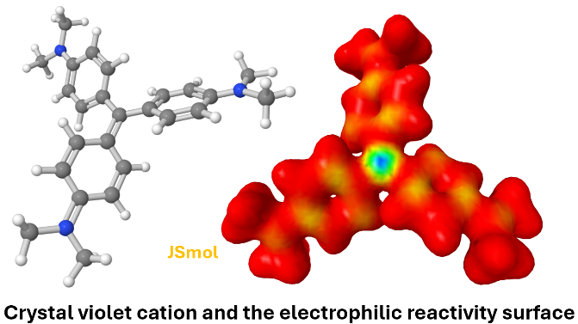

**KEYWORDS**

*Crystal Violet, DFT, ORCA, WebMO, JSmol, Transition State, Cluster, Activation Energy, LUMO, HOMO, UV-VIS, First-Year Undergraduate/General Chemistry*

## **INTRODUCTION**

Computational chemistry has been gradually introduced into the chemistry curriculum during the past decades as computational methods have become more common in chemistry research and as the power of computational hardware has increased. Published computational exercises have been mostly designed for upper division chemistry courses that delve into computational mathematics or organic mechanism details. These have often required specialized computational software that is installed in a computer lab accessible only to the small upper division classes or a general chemistry honors section.1 Rarely, entire classes gain access to such facilities.2-4

The potential user base for computational chemistry instruction has widened with the introduction of the WebMO program.5 WebMO has a number of features that recommend it for use in large enrollment classes: it requires no software installation by the user besides a web browser; it can use a variety of computational packages including Gaussian, ORCA, MOPAC, xTB, GAMESS, and others; computational servers may be installed either locally or in the cloud; and jobs are saved in a database, allowing users to log back in after completing a calculation to check their results. Several general chemistry computational exercises using WebMO have been reported, with most focusing on VSEPR theory.6-8 Labs related to resonance9 and the inductive effect10 have also been reported. Esselman and Block used embedded WebMO molecular orbital files to teach a modified VSEPR theory.11 Computational chemistry has been introduced into secondary schools.12

To date, computational applications in general chemistry deal mostly with the geometries of small molecules7,12 and the bond orders and molecular orbitals (MOs) of resonance stabilized ions.9 The study of larger chemical systems faces certain barriers. Unless they are carefully designed, density functional theory (DFT) calculations on large molecules often cannot be completed within a typical lab period. Even using software with a user-friendly interface, the complete build-optimize-analyze cycle for a larger molecule is still challenging and time consuming.

This article describes our approach to large molecule DFT calculations in general chemistry, which utilizes interactive webpages and single point calculations in WebMO. The molecules in question occur in the crystal violet (CV) alkaline hydrolysis reaction, which is the subject of a kinetics experiment earlier in the semester. Based on the calculation results, students analyze resonance stabilization and charge distribution within CV, calculate energies of activation and reaction, and use HOMO-LUMO energy gaps to predict UV-VIS spectra.

## **ALKALINE HYDROLYSIS OF CRYSTAL VIOLET**

CV reacts with aqueous NaOH to give the colorless crystal violet alcohol (CVOH) (Equation 1). The reaction progress is followed by measuring the decrease in the CV absorbance at the 590 nm λmax. This fact, and the slow reaction rate, make the experiment suitable for a general chemistry lab.13-16 Kinetics studies on this second-order reaction have been reported by Richie et al.17,18 and others.19-22 CV reacts slowly compared to other triarylmethyl cations due to the strong stabilization of its cationic center by three dimethylaminophenyl substituents.

Hydroxide ions are strongly hydrogen-bonded in water as shown by both experiment23-25 and theory.26-33 Molecular dynamics simulations of aqueous NaOH show 3, 4 or 5 waters donating H-bonds to the hydroxide O. The calculations in this exercise use a bridged 4-water-OH- cluster (Fig. 1), which is the most stable 4-water-OH- geometry at this level of theory (See Supporting Information).26 Thus, the activation barrier in this reaction arises from loosening and breaking H‑bonds to hydroxide. This cluster size gives an activation energy of 6.8 kcal mol-1 and a reaction energy of ‑10.5 kcal mol-1. These are somewhat low compared to Richie’s experimental enthalpy of activation ΔH‡ of 15.3 kcal mol-1 and ΔHorxn of -6.6 kcal mol-1.17 Larger clusters give more accurate values but require longer calculation times. These calculations use the solvation model density (SMD) theory34 where the molecules are surrounded by a polarizable surface that mimics a molecule’s interaction with the bulk water environment. Without the polarizable surface, i.e. in the gas phase, DE for the CV + OH-4wat 🡪 CVOH-4wat reaction is ‑78 kcal/mol. The gas phase model is missing the large aqueous solvation energies that stabilize the ionic reactants.

These molecules and their water complexes are first presented to students on interactive JSmol webpages from which the structure files are downloaded. These include CV and CVOH; and 4-water clusters of OH-, CVOH, and the CV-OH transition state.35 A frequency calculation on the transition state-OH-water cluster showed an imaginary vibration along the hydroxide-CV reaction coordinate. The others are energy minima with all real vibrations.

Figure 1. Reactants, transition state, and product of the crystal violet alkaline hydrolysis as they appear on each interactive webpage: (a) 4-water-OH- cluster, (b) crystal violet cation, (c) 4-water-OH-crystal violet transition state, (d) 4-water-crystal violet alcohol complex. Hydrogen bonds are cyan; the O-C reacting bond is red; OH oxygen is fuchsia.

## **INSTRUCTIONAL SETTING**

University of Alaska Fairbanks has an American Chemical Society–approved chemistry major program. The science and engineering major general chemistry series is offered each semester; an atoms-first textbook is used. The course enrolls about 140 students in the spring semester and 60 in the fall. Lab classes have a maximum of 20 students and are taught by graduate students or final-year undergraduates.

## **LEARNING OBJECTIVES**

The goal of this lab is to reveal the molecular phenomena occurring during a simple addition reaction, and the power of quantum theory to illuminate these phenomena. The DFT calculations provide quantitative and graphical descriptions that supplement traditional concepts of resonance, bonding in Lewis formulas, electronegativity, bond polarity, exo- and endothermic reactions, transition states, and the electromagnetic spectrum. Some of these are addressed in Parts A-C of the worksheet (see Supporting Information).

The overall learning objectives are:

(i) Understand that crystal violet cation is a hybrid of several resonance structures which show the ion’s positive charge being equally shared over all three branches of the molecule.

(ii) Be able to relate the calculated energy content of reactants, transition state, and product to a reaction energy diagram. Understand that the energy changes during the crystal violet-hydroxide reaction are due to breaking and making bonds.

(iii) Understand how the color loss that accompanies conversion of crystal violet to crystal violet alcohol is due to the increase in the HOMO-LUMO energy gap. Use the calculated HOMO-LUMO energy gap DE, Planck’s constant (h), the energy equation DE = hν to calculate approximate λmax‘s for crystal violet and crystal violet alcohol.

Part A: *Partial charges and resonance.* Electronegativity differences in bonded atoms cause partial charge separations, which are estimated as part of a single point energy calculation in ORCA.36 WebMO reports Loewdin partial atomic charges in the View Job page and students record values for the three N atoms on the worksheet. Scaffolding is provided in the student handout by a discussion of partial atomic charges in HF, NH3, NH4+, and the CV cation (see Supporting Information).

This section of the lab addresses the computational evidence for resonance in CV. To refresh memories, resonance in the formate ion is discussed in the handout. The Lewis formula of CV (Eq. 1) shows one nitrogen with a +1 formal charge. However, the DFT calculation reveals that the partial charges on all the N atoms are identical (-0.038). In addition, the bond lengths in the three aryl groups are invariant, and the electron density and electrostatic potential surfaces appear to be 3-fold symmetric. Thus, CV is a hybrid of 3 (or more) formulas. The worksheet asks students to fill in missing multiple bonds and formal charges in skeletal formulas, and to explain their answers in terms of the symmetry perceived in the surfaces.

Part B: *Activation and reaction energies*. Students calculate these energies using the ORCA output, then locate the reactants, transition state and products on a plot of the relative energies. The logic of energy scales is not always obvious. This is especially true when the absolute energies of reactants and products are all negative, as they are for quantum calculations that incorporate both core and valence electrons. The pre-lab for the experiment provides practice in dealing with negative energies in a small ΔErxn calculation.

Part C: *UV-vis spectroscopy and the electromagnetic spectrum*. *Why is CV violet, while CVOH is colorless?* This section builds on previous knowledge about atomic emission and absorption spectra, and the MOs of diatomic molecules. Here the orbitals in question are the HOMO and LUMO, which can be viewed in WebMO. Values for λmax of CV and CVOH are calculated from HOMO-LUMO energy differences, which are then substituted into ΔE=hν.

Assuming that the spectral absorbance is due mainly to promotion of an electron from the HOMO to LUMO, the calculations yield λmax values of 465 nm for CV and 254 nm for CVOH. These are not close to the experimental values of 590 nm and 280 nm; however, they do allow students to assign the absorbances to the correct spectral range, i.e., visible and ultraviolet. This discrepancy occurs because upon promotion of an electron, the LUMO and other MO’s change in a way that reduces the required excitation energy. The observed absorption wavelength is thus longer than expected based on the LUMO-HOMO gap of the ground state. Various advanced theoretical analyses of the CV absorption spectrum have been published.37,38

More practically, this lab shows students how to use WebMO and ORCA to carry out basic quantum theory calculations. In future chemistry classes or projects, these students hopefully will be more adept at using computational methods. To this end, WebMO sites ideally can be made available throughout the semester, allowing students to import or build molecules and carry out simple calculations at any time.

## **WORKSHEET RESULTS**

In the Spring 2025 semester, this exercise was completed within the 3-h lab, including all ORCA calculations and filling out the worksheet. The main benefit of this policy was to allow the teaching assistants to offer advice to the class and to consult with individuals. One hundred twenty-five students completed the worksheet, although several did not finish on time. Scores ranged from 63% to 100% with an average of 89%. A chart of scores by topic is in the Supporting Information (Fig. S1, Table S1).

The general trend was that students did well on the mathematical calculations of λmax (93%) and DE (76%) that utilize skills of dimensional analysis, unit conversions, and scientific notation already heavily emphasized in both general chemistry semesters. Where some students tripped up was applying DE’s to the reaction progress graph (62%) and giving a cogent explanation for why the energy first increases then decreases going to the product (61%). It did not seem to help that the latter answer is contained in Fig. 2 of the lab handout. Another area of difficulty was drawing Lewis structures of the H2O-OH- complex in the pre-lab (59%) and adding formal charges and double bonds in the CV cation resonance forms (61%). This is a difficult concept even when addressed head-on in first semester general chemistry.

## **JSmol INTERACTIVE WEBPAGES**

In our experience, students encounter various difficulties with molecular modeling software especially when they must build and optimize a molecule. Optimizing the structure once it is built may require many minutes, and even then, a geometry optimization job may arrive at an incorrect isomer or conformer. Our work-around is to provide optimized structures in easy-to-understand graphical format that can be imported into the WebMO workspace. A 1-2-min energy calculation then provides relevant details such as energy content, charge distribution, and bond distances.

Fig. 2 shows three of the pages that introduce students to crystal violet quantum calculations.35 The upper portion of the index page (a) links to sub-pages showing the structures in Fig. 1 and CVOH. Right-clicking one of the JSmol molecule pages brings up a menu offering to save the structure on the local computer in the molfile format (.mol). After logging into WebMO, the File, Import Molecule menu is used to bring the molecule into the workspace. The lower portion of the index page (b) and (c) show pages that are not downloaded but which illustrate the surfaces of CV discussed in Part A of the worksheet. The total electron density surface (b) provides visual evidence that CV is completely symmetric despite the formula showing only one resonance form. The electrostatic potential surface (c) illustrates the electroneutrality of the central carbon (green color) and the buildup of valence electrons near π-bonds and N atoms (yellow and red). The electrophilic reactivity surface (see the abstract graphic) shows the amplitude of the LUMO at about 1.2 Å above the C and N atoms. The electron-rich hydroxide ion attacks CV on the central C where the amplitude of the LUMO is maximal.

Rotating a molecule on a JSmol interactive webpage or in WebMO helps one perceive its overall shape better than viewing a static image. Rotation provides important visual clues about the 3D shape of the object. On the other hand, comprehending the shape of an unfamiliar object such as crystal violet cation based on a stationary image, as students sometimes try to do, is nearly impossible. These webpages contain directions on how to rotate with the mouse and a button in the right panel that automatically spins the molecule.

HTML files for the JSmol webpages are in the Supporting Information. JSmol, the web version of the Jmol molecular graphics program,39 requires that JSmol program files be installed along with the interactive webpages.

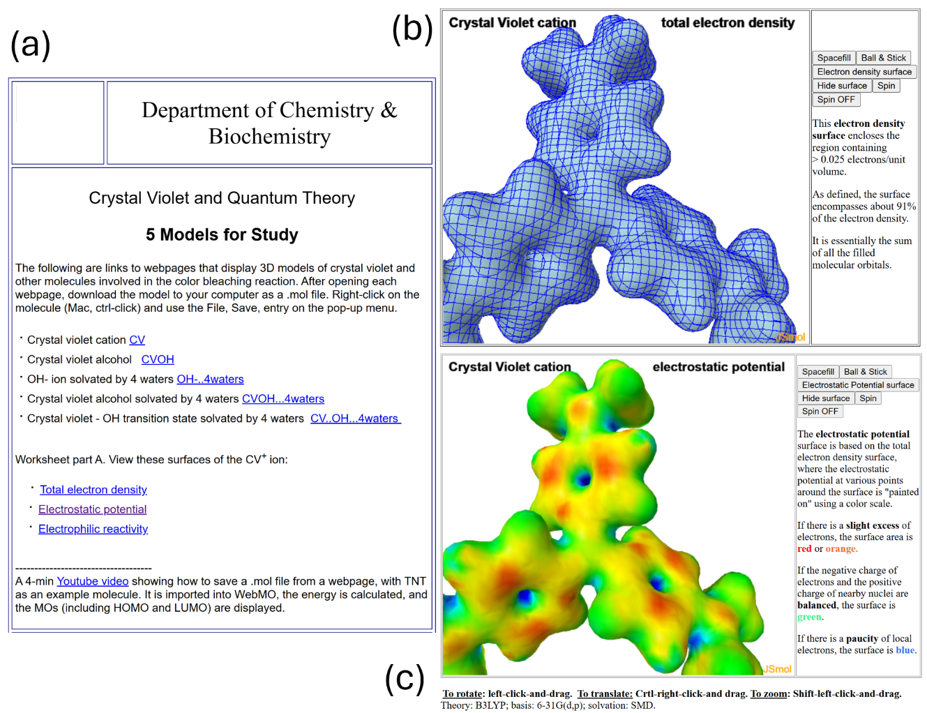

Figure 2. (a) Index page with links to interactive molecular pages, (b) JSmol page linked from the “Total electron density” entry on the index page, (c) JSmol page linked from the “Electrostatic potential” entry on the index page. The JSmol pages contain explanatory notes and interactive buttons that show or hide mapped isosurfaces. The JSmol page linked from the “Electrophilic reactivity” entry is shown in the abstract graphic.

## **WEBMO AND COMPUTE SERVERS**

To simplify student job input and speed up calculations, WebMO was customized in three ways: (1) the orca.html file was edited to set the default method as B3LYP; default basis set as 6-31G(d,p); multiplicity as singlet; solvent as water; and the number of cores as 8. (2) Using the Template Manager, a custom template was created, which is a copy of the ORCA Molecular Energy template but with an additional section specifying the SMD polarizable continuum model.34 See the Supporting Information for an example input file. (3) In WebMO, the charge setting in the Job Options page is read from column 6 of an imported .mol file. These are zero for all atoms of the downloaded structures except the quaternary N of CV. To force the correct automated entry of +1, the cv-orc.mol file stored on the JSmol webserver must be modified to read +3 for this atom.

To further speed up calculations, the WebMO Remote Server and System Manager apps can be used to control the flow of jobs. Exactly how this is done will depend on the computing environment within a department. Using on-premises servers resulted in the calculations taking 1-2 minutes, even when there were two concurrent lab sections. Students completed the lab in 3 hours or less; therefore, most of the lab time was spent navigating the calculation View Job pages and completing the worksheet.

Three second semester general chemistry classes have completed this exercise: 7-section classes in 2024 and 2025, and a 3-section class in Fall 2024. The exercise was essentially the same in the three semesters, except that in one semester the background compute engine was Gaussian rather than ORCA. The molecular geometries, energies, charges, and surfaces are identical with the two programs.

## **LIMITATIONS**

The main limitation of this laboratory exercise is that it must be implemented by faculty and/or staff with expertise in webpage management, Linux or Windows operating systems, and installation and maintenance of WebMO and the ORCA computational software. Other limitations relate to the correlation of this lab with the local general chemistry curriculum: this exercise makes the most sense if it is preceded by the corresponding crystal violet kinetics laboratory and if MO theory has been covered earlier in the year.

## **CONCLUSIONS**

Crystal violet provides fertile ground for teaching general chemistry concepts, especially when the properties of the ion and the hydrolysis reactants and product can be computed. In this lab, less than 10 min of online computing uncover a wealth of details about the reaction that had previously been experienced only as a purple solution whose color fades. The details illustrate the effect of resonance on a molecule’s geometry and charge distribution; enable close inspection of a transition state and the factors behind its higher energy content; and emphasize the role that MOs, particularly the LUMO, play in color production and chemical reactivity.

We show here that density functional theory calculations on large molecules can be carried out in a timely fashion by students in a general chemistry lab. To make this possible we installed WebMO and the ORCA computational program; slightly modified WebMO to define default computational parameters that minimize calculation wall times; connected remote compute servers to WebMO; and provided the optimized structures on interactive webpages.

Associated content

Supporting Information

The Supporting Information is available on the ACS Publications website at DOI: 10.1021/acs.jchemed.XXXXXXX.

Notes to Instructors 2025 (Directions for webpages; WebMO and compute servers; alternative implementations) (PDF)

Other Supporting Information (Worksheet scores; cyclic OH-water complexes; ORCA input file; CV thermodynamic parameters) (PDF)

Materials (Pre-lab; student handout; worksheet; and keys (7 PDFs, zip file))

Glossary (PDF)

Cartesian coordinates (PDF)

Interactive molecular website including file structure, index, html, mol, and jvxl files (zip file)

## **ACKNOWLEDGMENTS**

This project was supported by the University of Alaska Fairbanks Department of Chemistry and Biochemistry and the University of Alaska Foundation.

## **References**

1. Ruddick, K. R.; Parrill, A. L.; Petersen, R. L. Introductory Molecular Orbital Theory: An Honors General Chemistry Computational Lab As Implemented Using Three-Dimensional Modeling Software. *J. Chem. Educ.* **2012**, *89* (11), 1358-1363.

2. Paselk, R. A.; Zoellner, R. W. Molecular Modeling and Computational Chemistry at Humboldt State University. *J. Chem. Educ.* **2002**, *79* (10), 1192.

3. Feller, S. E.; Dallinger, R. F.; McKinney, P. C. A Program of Computational Chemistry Exercises for the First-Semester General Chemistry Course. *J. Chem. Educ.* **2004**, *81* (2), 283.

4. Metz, I. K.; Bennett, J. W.; Mason, S. E. Examining the Aufbau Principle and Ionization Energies: A Computational Chemistry Exercise for the Introductory Level. *J. Chem. Educ.* **2021**, *98* (12), 4017-4025.

5. Polik, W. F.; Schmidt, J. R. WebMO: Web-based computational chemistry calculations in education and research. *WIRES Comp. Mol. Sci.* **2022**, *12* (1), e1554.

6. Medrano, A. L.; Gilbert, T. M.; Morales, C. M. Shortcomings of the VSEPR Model for Hypercoordinate Species and Its Presentation in General Chemistry. *J. Chem. Educ.* **2023**, *100* (9), 3659-3666.

7. McNaught, I. J. Testing and Extending VSEPR with WebMO and MOPAC or GAMESS. *J. Chem. Educ.* **2011**, *88* (4), 421-425.

8. Martin, C. B.; Vandehoef, C.; Cook, A. The Use of Molecular Modeling as “Pseudoexperimental” Data for Teaching VSEPR as a Hands-On General Chemistry Activity. *J. Chem. Educ.* **2015**, *92* (8), 1364-1368.

9. Santos, A. V. B.; Rupprecht, A. J.; Ogawa, K.; Schneider, P. W.; Brown, A. M.; Santos, H. C.; Simpson, S. Exploring Student Misconceptions in Bonding and Resonance: A Computational Chemistry Exercise for General Chemistry Laboratory. *J. Chem. Educ.* **2024**, *101* (10), 4381-4389.

10. Stepanova, V. A.; West, J. K. Exploring the Inductive Effect through Computational Modeling: A General and Organic Chemistry Lab Experiment. *J. Chem. Educ.* **2024**, *101* (7), 2815-2822.

11. Esselman, B. J.; Block, S. B. VSEPR-Plus: Correct Molecular and Electronic Structures Can Lead to Better Student Conceptual Models. *J. Chem. Educ.* **2019**, *96* (1), 75-81.

12. Hrubeš, J.; Jaroš, A.; Nemirovich, T.; Teplá, M.; Petrželová, S. Integrating Computational Chemistry into Secondary School Lessons. *J. Chem. Educ.* **2024**, *101* (6), 2343-2353.

13. Cannon, J. F.; Gammon, S. D.; Hunsberger, L. R. KineticsLab: The Crystal Violet/Sodium Hydroxide Reaction. *J. Chem. Educ.* **1994**, *71* (3), 238.

14. Corsaro, G. Colorimetric chemical kinetics experiment. *J. Chem. Educ.* **1964**, *41* (1), 48.

15. Kazmierczak, N.; Vander Griend, D. A. Improving Student Results in the Crystal Violet Chemical Kinetics Experiment. *J. Chem. Educ.* **2017**, *94* (1), 61-66.

16. Knutson, T. R.; Knutson, C. M.; Mozzetti, A. R.; Campos, A. R.; Haynes, C. L.; Penn, R. L. A Fresh Look at the Crystal Violet Lab with Handheld Camera Colorimetry. *J. Chem. Educ.* **2015**, *92* (10), 1692-1695.

17. Ritchie, C. D.; Wright, D. J.; Huang, D. S.; Kamego, A. A. Cation-anion combination reaction. XII. Rates, equilibriums, and activation parameters for reactions of triarylmethyl cations in aqueous solution. *J. Am. Chem. Soc.* **1975**, *97* (5), 1163-1170.

18. Ritchie, C. D.; Skinner, G. A.; Badding, V. G. Solvent Effects on the Reactions of Stabilized Carbonium Ions with Nucleophiles. *J. Am. Chem. Soc.* **1967**, *89* (9), 2063-2071.

19. Salahudeen, N.; Rasheed, A. A. Kinetics and thermodynamics of hydrolysis of crystal violet at ambient and below ambient temperatures. *Sci. Rep-UK* **2020**, *10* (1), 21929.

20. Beach, S. F.; Hepworth, J. D.; Mason, D.; Swarbrick, E. A. A kinetic study of the hydrolysis of crystal violet and some terminal and bridged analogues. *Dyes Pigments* **1999**, *42* (1), 71-77.

21. Fox, B. M.; Hepworth, J. D.; Mason, D.; Hellas, G. The hydrolysis of Brilliant Green and some derivatives. Part 2. The kinetics of the hydrolysis of 3- and 4-substituted derivatives of Brilliant Green. *J. Chem. Soc., Perkin Trans. 2* **1982**, (8), 987-991, 10.1039/P29820000987.

22. Ritchie, C. D. Cation–anion combination reactions. 26. A review. *Can. J. Chem.* **1986**, *64* (12), 2239-2250.

23. Botti, A.; Bruni, F.; Imberti, S.; Ricci, M. A.; Soper, A. K. Solvation of hydroxyl ions in water. *J. Chem. Phys.* **2003**, *119* (10), 5001-5004.

24. Mandal, A.; Ramasesha, K.; De Marco, L.; Tokmakoff, A. Collective vibrations of water-solvated hydroxide ions investigated with broadband 2DIR spectroscopy. *J. Chem. Phys.* **2014**, *140* (20), 204508.

25. Marx, D.; Chandra, A.; Tuckerman, M. E. Aqueous Basic Solutions: Hydroxide Solvation, Structural Diffusion, and Comparison to the Hydrated Proton. *Chem. Rev.* **2010**, *110* (4), 2174-2216.

26. Bankura, A.; Chandra, A. Hydration structure and dynamics of a hydroxide ion in water clusters of varying size and temperature: Quantum chemical and ab initio molecular dynamics studies. *Chem. Phys.* **2012**, *400*, 154-164.

27. Bryantsev, V. S.; Diallo, M. S.; van Duin, A. C. T.; Goddard, W. A., III. Evaluation of B3LYP, X3LYP, and M06-Class Density Functionals for Predicting the Binding Energies of Neutral, Protonated, and Deprotonated Water Clusters. *J. Chem. Theory Comput.* **2009**, *5* (4), 1016-1026.

28. Chen, M.; Zheng, L.; Santra, B.; Ko, H.-Y.; DiStasio Jr, R. A.; Klein, M. L.; Car, R.; Wu, X. Hydroxide diffuses slower than hydronium in water because its solvated structure inhibits correlated proton transfer. *Nat. Chem.* **2018**, *10* (4), 413-419.

29. Choi, T. H.; Liang, R.; Maupin, C. M.; Voth, G. A. Application of the SCC-DFTB Method to Hydroxide Water Clusters and Aqueous Hydroxide Solutions. *J. Phys. Chem. B* **2013**, *117* (17), 5165-5179.

30. Lemke, K. H. Structure and solvation dynamics of the hydroxide ion in ice-like water clusters: a CCSD(T) and car–parrinello molecular dynamics study. *Phys. Chem. Chem. Phys.* **2021**, *23* (34), 18990-18998, 10.1039/D1CP02524D.

31. Liu, R.; Zhang, C.; Liang, X.; Liu, J.; Wu, X.; Chen, M. Structural and dynamic properties of solvated hydroxide and hydronium ions in water from ab initio modeling. *J. Chem. Phys.* **2022**, *157* (2).

32. Shi, H.; Gong, L.-D.; Liu, C.; Lu, L.-N.; Yang, Z.-Z. ABEEM/MM OH– Models for OH–(H2O)n Clusters and Aqueous OH–: Structures, Charge Distributions, and Binding Energies. *J. Phys. Chem. A* **2020**, *124* (28), 5963-5978.

33. Sun, X.; Yoo, S.; Xantheas, S. S.; Dang, L. X. The reorientation mechanism of hydroxide ions in water: A molecular dynamics study. *Chem. Phys. Lett.* **2009**, *481* (1), 9-16.

34. Marenich, A. V.; Cramer, C. J.; Truhlar, D. G. Universal Solvation Model Based on Solute Electron Density and on a Continuum Model of the Solvent Defined by the Bulk Dielectric Constant and Atomic Surface Tensions. *J. Phys. Chem. B* **2009**, *113* (18), 6378-6396.

35. Keller, J. W. *Crystal Violet and Quantum Theory*. University of Alaska Fairbanks, 2025. <https://antec12.cns.uaf.edu/cv-expt/index-orca.html> (accessed 2025 Feb. 1).

36. Neese, F. Software update: the ORCA program system, version 5.0. *WIRES Comput. Molec. Sci.* **2022**, *12* (1), e1606.

37. Bashirova, D.; Zuehlsdorff, T. J. First-Principles Modeling of the Absorption Spectrum of Crystal Violet in Solution: The Importance of Environmentally Driven Symmetry Breaking. *J. Phys. Chem. A* **2024**, *128* (27), 5229-5242.

38. Sissaoui, J.; Budkina, D. S.; Vauthey, E. Torsional Disorder, Symmetry Breaking, and the Crystal Violet Shoulder Controversy. *J. Phys. Chem. Lett.* **2023**, *14*, 5602-5606.

39. Hanson, R. M.; Prilusky, J.; Renjian, Z.; Nakane, T.; Sussman, J. L. JSmol and the next-generation web-based representation of 3D molecular structure as applied to Proteopedia. *Israel J. Chem.* **2013**, *53*, 207-216.