8-Dec-2023

John W. Keller, University of Alaska Fairbanks

Department of Chemistry and Biochemistry

jwkeller@alaska.edu

This example uses the output.log from an ORCA optimization job

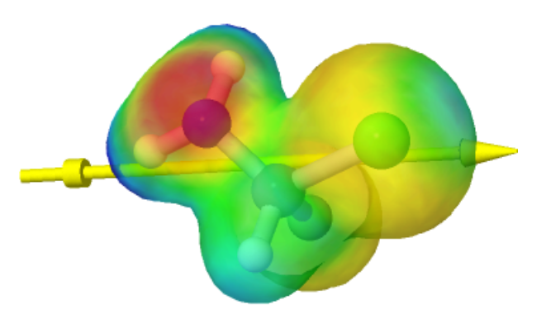Orca input.inp:

! B3LYP 6-31G(d,p)  
! OPT  
* xyz 0 1  
C 0.00000000 0.00000000 0.00000000  
N 1.40635900 0.00444500 -0.02777100  
H 1.77564700 0.95076400 -0.01696900  
H 1.78236900 -0.51878400 0.75806500  
F -0.54662700 0.66115000 1.08564100  
H -0.39093600 -1.01869200 -0.00145500  
Cl -0.64682900 0.82084200 -1.48130100  
*

In WebMO, export the structure as **fclma.mol**; export the electron density surface as **fclma-dens.cub**; export the electrostatic potential as **fclma-esp.cub**.

In WebMO the dipole moment is shown at the cartesian center and is about 2.5x the length of the dipole given in the  "Dipole Moment" table at the end of the ORCA output.log file.

For a given molecule, the dipole coordinates can be calculated from the dipole given in the ORCA table using a spreadsheet. See below.

(ORCA gives the dipole direction as defined by physicists. As chemists, we therefore take the negative of the initial dipole coordinates in output.log.) The ORCA dipole also originates at the cartesian origin (0,0,0), so this must be moved to the "WebMO" location in the spreadsheet. The spreadsheet creates a Jmol "dipole" command using the calculated dipole coordinates, which can then be pasted into the Jmol console (it has already been done in this example).

For your molecule, the (negative of the) dipole coordinates from the ORCA table should be entered in Row 11. The cartesian coordinates of the molecule are entered beginning at Row 27. The cartesian coordinates of the molecule can be obtained from the ORCA "CARTESIAN COORDINATES (ANGSTROEM)" table or exported in XYZ format from WebMO.

Using Jmol, the set of commands with comments are as follows:

cd <directory containing 3 files>  
load fclma.mol;  
background white;  
set antialiasdisplay on;  
color bonds gainsboro;  
zoom 100;  
dipole dip width 0.2 {1.3625 -0.3475 0.818} { -0.2625 0.6275 -0.632};  // dipole like WebMO  
color dipole blue;  
// dipole dip width 0.2 {3.15 -1.42 2.413} { -2.05 1.7 -2.227};// 8x dipole  
// color dipole yellow;  
isosurface esp cutoff 0.02 fclma-dens.cub color absolute -0.18 0.07 fclma-esp.cub;  
isosurface esp translucent 99;  
isosurface fullylit;  
// isosurface off;